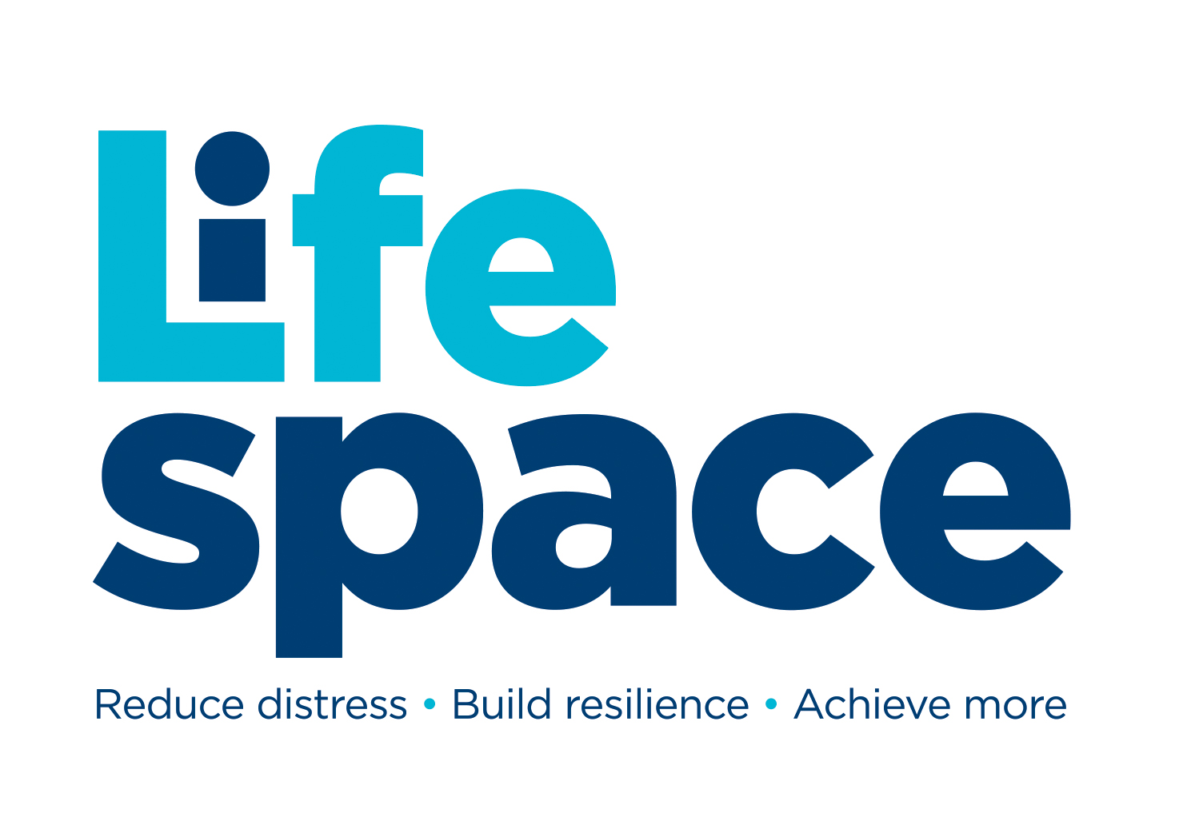
PARENT/CARER
ONE TO ONE MENTORING REQUEST FORM
“We mentor young people to reduce distress, build resilience & achieve more”

This form is for parents/carers' to complete on behalf of a young person. It's important that we have as much as information as possible so please complete all sections indicated. The information shared is strictly confidential and only for the attention of Lifespace Trust.

TELL US ABOUT THE YOUNG PERSON
Full Name
Preferred Name
Pronouns
Gender
Date of Birth
Young Person’s current address
Preferred session type | Face to Face / Phone / MS Teams / Any of these (please delete as appropriate)
Is the young person care experienced | Yes/No (please delete as appropriate)
Is there a child protection plan in place | Yes/No (please delete as appropriate)
Has there been an Early Help/Early Support/Family Help or Targeted support assessment | Yes/No (please delete as appropriate)
Does the young person receive pupil premium | Yes/No (please delete as appropriate)
Does the young person have a Stratford home postcode | Yes/No (please delete as appropriate)

TELL US ABOUT THE YOUNG PERSON’S SCHOOL/COLLEGE
Are they currently enrolled at a school/college | Yes/No (please delete as appropriate).
If they are enrolled in school/college please give us the name
Are they currently able to attend their school/college | Yes/No (please delete as appropriate)
Year group

Health Information
Doctor Surgery name
Doctor Surgery number
Does the young person have a special educational need | Yes/No (please delete as appropriate)
Has the young person been referred to CAMHS/RISE/GP | Yes/No  If yes which service?  GP/CAMHS/RISE (please delete as appropriate)
In relation to their health or medication, is there anything that would be useful for us, or a medical professional to know?

TELL US ABOUT THE REASON FOR REQUESTING MENTORING

Reasons for mentoring? Please include as much relevant information about the young person:

In what ways will mentoring address the issues? Please mention specific intended outcomes:

RISK ASSESSMENT - TELL US ABOUT CURRENT RISKS observed or known about:

Has the young person you are completing this on behalf of: | Never | Past 1-4 weeks | Past 1-6 months | Past 6-12 months | More than a year ago
Harmed themselves
(include use of alcohol/drugs):
Been harmed by others:
Inflicted harm on others:
Experienced loss:
Had thoughts of suicide:
Witnessed Domestic Abuse:

*Please note - we are willing to work alongside other professionals where:
1. The young person has already attempted suicide - contact should also be made with RISE / GP / CAMHS
2. There is a recent or expected family bereavement – also contact a specialist service
3. The young person is witness to domestic abuse / experienced physical abuse – also contact a specialist service

Does anything specific need to be considered to manage the risks with this request? Yes / No
If yes please give more details:

YOUR DETAILS (THESE WILL ALSO BE USED FOR INVOICING)
Name
Your Relationship to the young person
Contact number
Contact email
Contact address
Are you in receipt of any benefits? If Yes please specify which ones as we maybe able to offer fee waivered mentoring. | Yes/No (please delete as appropriate).
Emergency contact (for use if we are unable to contact you). Please include name, phone number and relationship to the young person.

TERMS, CONDITIONS AND PRIVACY POLICY

- If we consider it necessary in order to safeguard and/or promote a young person's welfare, we will contact DSL at school and/ or other agencies
- Ordinarily we will seek the young person’s consent (or parent's/carer's consent as necessary) but there may be occasions we do not, if doing so places young person at risk or causes delay
- The information shared on this form is strictly confidential and is only for the attention of Lifespace Trust. Its is not to be shared & must be stored securely.
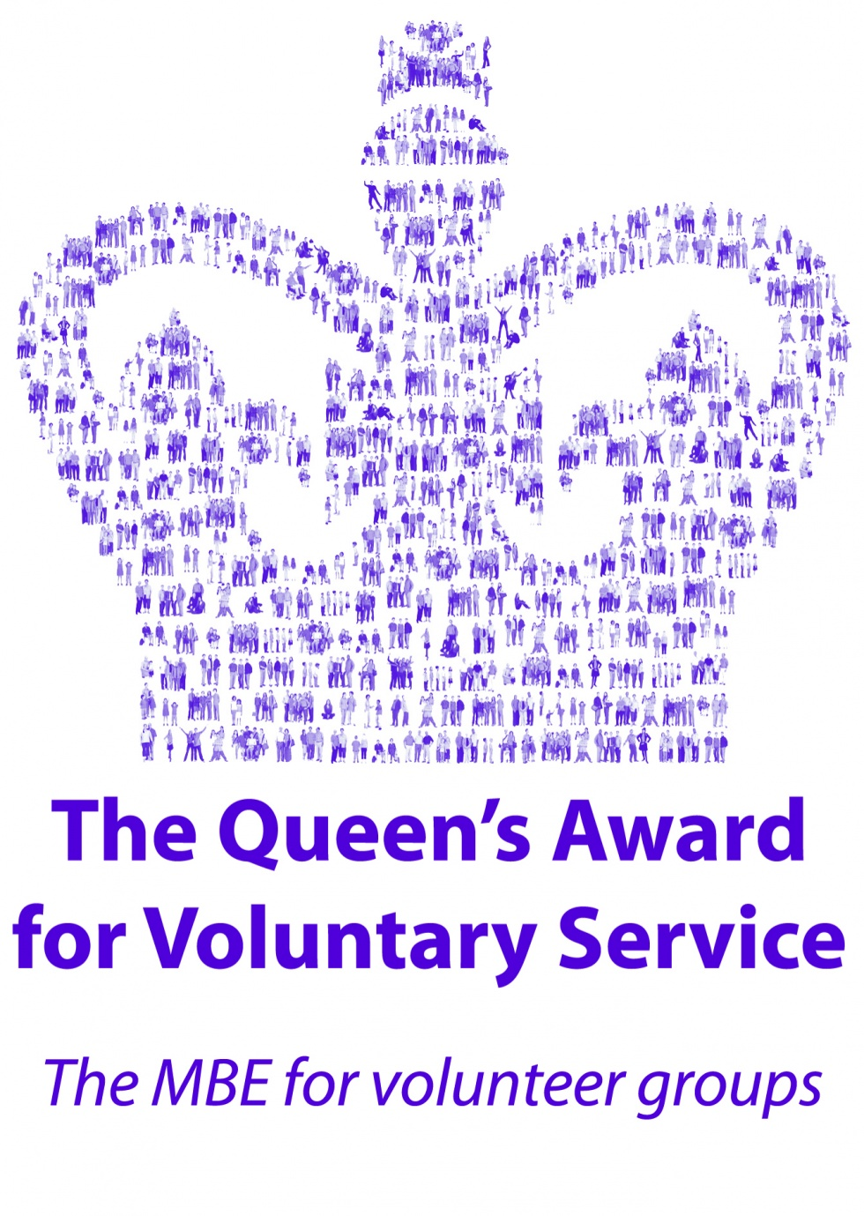
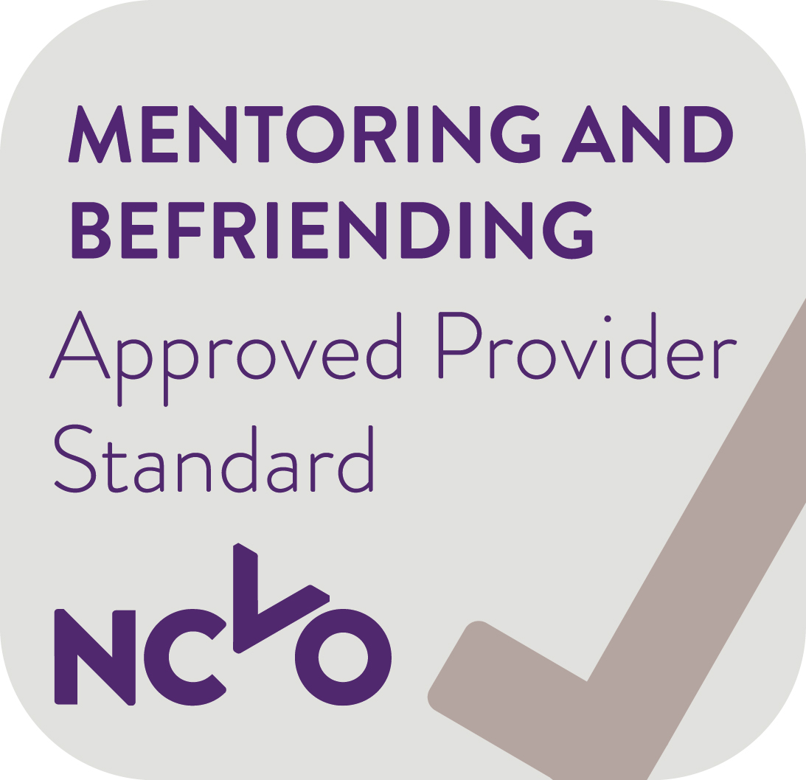
Lifespace Trust, Tyler House, Tyler St, Stratford-Upon-Avon, Warks. CV37 6TY
Tel: 01789 297400 Email: admin@lifespace.org.uk Web: www.lifespace.org.uk
Lifespace Trust is an Approved Provider & has been awarded The Queen’s Award for Voluntary Service

